.
20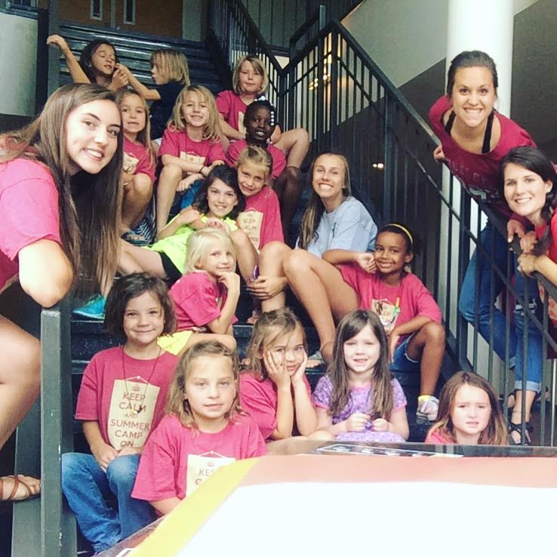 | August 2017
Sun. | Mon. | Tue. | Wed. | Thu. | Fri. | Sat.
 |  | 1 | 2 | 3 | 4 | 5
 |  | 1st – 3rd grade  Kid’s Planet |  | 4th – 8th grade  Sliding Rock  LEAVING AT  8 AM!! | Summer Camp Prom
6 | 7 | 8 | 9 | 10 | 11 | 12
 | Water Day | 1st – 2nd grade  Lunch at Pickwick and  Movies | 3rd- 4th grade  Lunch at Pickwick and  Movies | 5th – 8th grade  Lunch at Cheeseburger House and Movies | Nomadik Few
13 | 14 | 15 | 16 | 17 | 18 | 19
 | All Day  20.00 per day per child | All Day | All Day  PIZZA PARTY!! | CLOSED | CLOSED
20 | 21 | 22 | 23 | 24 | 25 | 26
 | After school and Summer Camp closed. Office Open | First Day of School!!
27 | 28 | 29 | 30 | 31

Notes | **Sliding Rock Field Trip: Leaving at 8 am!! Please bring swimsuit, towel, bag lunch, and change of clothes  Prom is from 7pm -9 pm  I will supply candy for movie but if you want your child to have a soda or popcorn you need to supply around $7.

